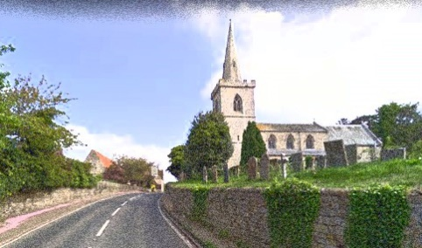**Wellingore Parish Council**

Notes of the Parish Council Meeting

Monday 9th June 2025 at 7pm  
  
*Please be advised that these are notes of the meeting taken by the Clerk and cannot in any way be regarded as the official minutes of council proceedings until they are approved and signed at the next meeting.*

Present: Cllr Niall Shaw (Chair), Cllr Paul Hathaway, Cllr Ben Hausermann, Cllr Alex Theaker, Cllr Karen Mitchener, Cllr Catherine Mills, Cllr Lucille Hagues

Clerk: Chantelle Hausermann

Apologies: Cllr Mountjoy, Cllr Reid

**/1 Public Forum**Nil

**/2**  **To receive apologies and reasons given.**

Cllr Hauserman, Cllr Mountjoy

**/3 To approve the notes of the meeting held on Monday 12th May 2025**

Proposed Cllr Theaker, Seconded Cllr Mills – All in agreement.

**/4 To receive declarations of interest on any item on the agenda.**

Cllr Hausermann and the Parish Clerk declared an interest in Item 9 point 2.

**/5 To discuss matters arising.**

1. **to provide an update on Fosse Green and Springwell Farm including Coleby batteries.**

The letter from the CSVAG to Parish Council has been shared. The Parish Council will review and consider next steps. **ONGOING**

1. **to provide and update on the church floodlights.**

Cllr Shaw will purchase the floodlights as agreed at the previous meeting and will arrange an install. **ONGOING**

1. **to provide an update on Navenby FC.**

Navenby FC would like to line out two pitches for use by their junior teams for the next football season. Consideration is being given to the grass cutting vs lease of the field. The FA have inspected the pitches. **ONGOING**

1. **to provide an update on the picnic table and approve the quotation provided.**

The parish council thanked the Residents Association for their donation of £600. The parish council agreed the purchase of the Clifton Picnic Table at £660.51 excluding VAT. The plaque to be fitted will be arranged. The picnic table will be positioned in the far end of the playing field near the apple trees.

**ACTION: Parish Clerk to order**

/**6 Councillors Reports.**

**/1 Councillor L Hagues** – June Newsletter shared. Cllr Hagues had nothing further to add.

**/2 Councillor M Overton** – Not in attendance.

**/7 To consider matters for discussion and resolution**

1. **to discuss a donation to the Graffoe Link**

A contribution was made last year. The parish council agreed unanimously to repeat the donation at the same figure as the previous year. **Item Closed.**

1. **to discuss the MH & Field Land Registry.**

The parish council address is to be changed with the Land Registry.

1. **to discuss the Scout Hut lease and next actions.**

A copy of the lease has been obtained by the Parish Council. A new lease will be drafted and issued to the scout hut. It is a peppercorn lease and no money exchanges hands.

**d. to discuss welcome to Wellingore Information Boards.**

The boards are now being produced. The parish council are liaising with the Friends of the Church. The council are trying to obtain the old photos to support this project.

**/8 To note correspondence received:**

No comments.

**/9 Planning**

**• Application 25/0027/HOUS – The Barn, Barnes Lane**

**• Application 25/0399/HOUS – 7 Memorial Hall Drive, Wellingore**

**• Application 25/0442/VARCON Walnut Tree Field**

No comments.

**/10 Finance**

To confirm the bank balances on 5th June 2025 and agree payments by BACs

Current account as at 05.06.2025 £27,044.18

Deposit account as at 05.06.2025 £22,094.66

The AGAR 2024/25 was reviewed and agreed. The documents were signed.

The Notice of Public Rights and Publication of Unaudited Accounts were announced commencing on the 10th June to 21st July 2025.

**/11 To discuss any other business.**

The trees were discussed on the far side of Jubilee Gardens, a tree inspection will be organised.

**/12** To note the date of the next meeting: 14th July at 7pm – to be confirmed.

The Chairman thanked all for attending and closed the meeting at

signed....................................................................... dated.....................................................

Chantelle Hausermann - Parish Clerk

[wellingoreclerk@live.co.uk](mailto:wellingoreclerk@live.co.uk)

07791113860

List of payments approved: